[Riverlabs logo]

Manual: Digi Cellular Xbee 3G

**Introduction**

The Digi XBee Cellular Modems are a series of radio devices for embedded applications. Apart from being pre-certified and industry-grade, their main advantage is the use of a specific API that is common to the whole range Digi radio devices, which includes other radio technologies and protocols such as Zigbee. This makes it gives a large flexibility when designing network solutions for particular applications, both wide and local networks, and to upgrade devices.

For the Riverlabs range of loggers, we use the Cellular 3G modem [1] as default for cellular connectivity. Digi also has solutions for 4G, but these rely on the LTE-M or NB-IoT protocols, both of which are not very common yet. However, it should be straightforward to upgrade.

The Xbee modems also come with a very comprehensive manual [2]. This guide is intended as a shorter introduction to get started quickly. But for advance use, it is highly recommended to study the manual in detail.

**Programming the Xbee**

***Connecting the serial port***

Xbee devices come with a few different digital interfaces, including UART and SPI. The UART serial interface is most convenient to work with, and is also what Riverlabs loggers use. The Xbee can be programmed fully via Arduino code, but it is more convenient to program it first by connecting it directly to a computer.

Digi sells a development board, the XBIB [3], which comes with all bells and whistles and its use is described in the Xbee manual. However, any USB-to-serial adapter can be used and many adapters exist. Most of those are based on the FTDI chip, such as the Sparkfun Xbee Explorer [4]. To use those you may need to install the FTDI drivers if you use Windows, or set some permissions to be set on Linux. Sparkfun has a great manual [5] if you experience problems with your PC not recognizing the serial adapter.

It is also important to note that FTDI adapters typically come as either 3.3V and 5V versions. XBees are strictly 3.3V devices so you should never use 5V FTDI adapters or you may damage your Xbee. Some adaptors have a switch to set the voltage. In that case, make sure that it is set correctly.

[Photo of Xbee connected via FTDI adapter]

***Using the XCTU software***

It is most convenient to use Digi’s XCTU software to program an XBee via a PC. XCTU can be downloaded for free from Digi website [6].

XCTU is also well documented in the user manual, so here we focus only on the steps that are relevant for operating the Riverlabs loggers. The main steps to connect to the Xbee are outlined in Figures 2 and 3.

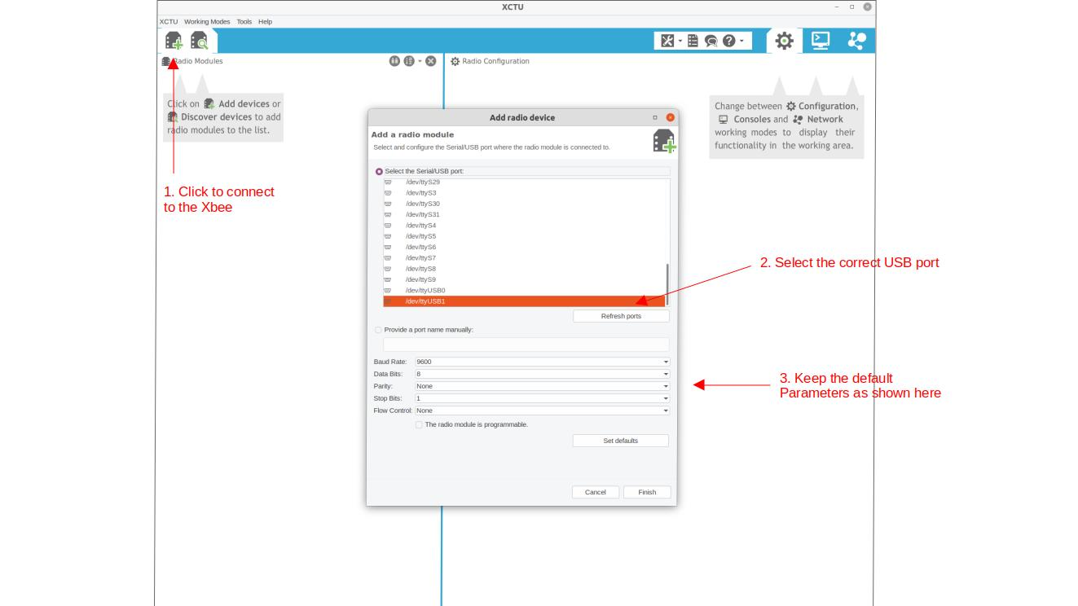

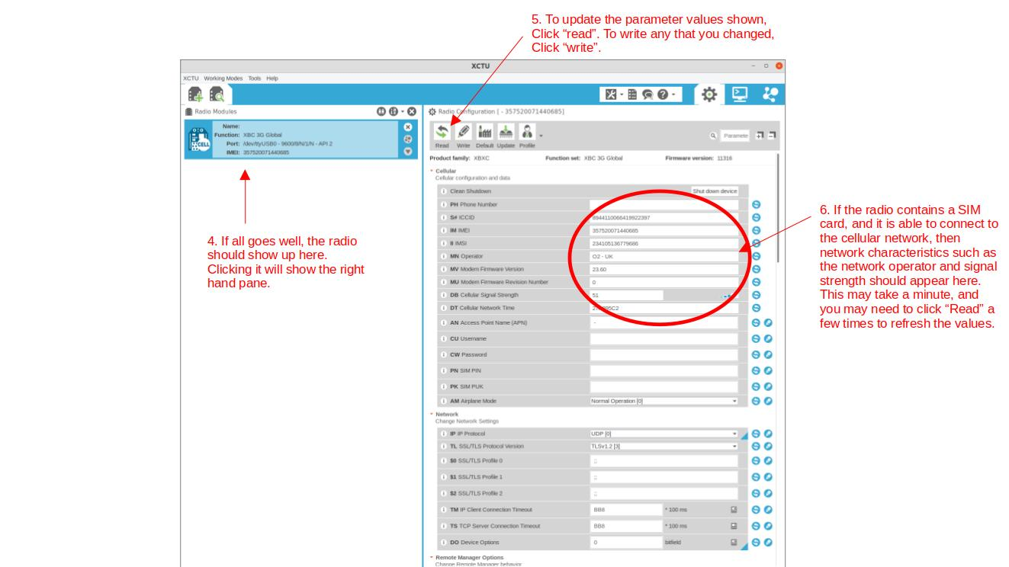

**References**

[1] https://www.digi.com/products/embedded-systems/digi-xbee/cellular-modems/digi-xbee-cellular-3g

[2] https://www.digi.com/resources/documentation/Digidocs/90001541/

[3] https://www.digi.com/products/models/xbib-u-dev

[4] https://www.sparkfun.com/products/11812

[5] https://learn.sparkfun.com/tutorials/how-to-install-ftdi-drivers/all

[6] https://www.digi.com/products/embedded-systems/digi-xbee/digi-xbee-tools/xctu